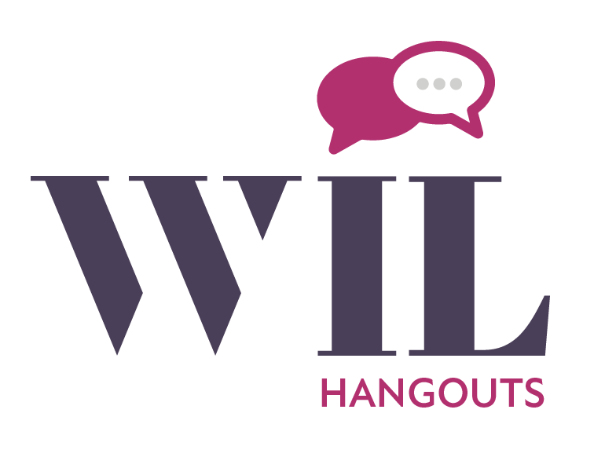

Host a Hangout

WIL Hangouts are one-time po up events designed to highlight what you’re passionate about and a great way to develop your leadership skills.

Ideas / Options for a successful Hangout:
- Plan ahead – submit form 1-2 weeks in advance for a better turnout
- Choose a fun location
- Provide product samples
- Offer discounted services
- Door prizes / drawings
- Provide appetizers

WIL Member / Host Name:_______________________________________________________________

Hangout Date & Time:___________________________________________________________________

Place:________________________________________________________________________________

Email / Phone:_________________________________________________________________________

Hangouts are WIL endorsed, led by WIL members.

Hangouts must be hosted by a WIL member in good standing. Host is responsible for marketing Hangout. WIL Hangout logo must be used in all marketing. Hangout Host may sell or demonstrate products / services.

Members Only Facebook page: https://www.facebook.com/groups/WILMembersonly

Turn in request form at WIL event or luncheon or send to jpricetober@gmail.com or mail to WIL Events Committee, P.O. Box 6717, Saginaw, MI, 48608.

