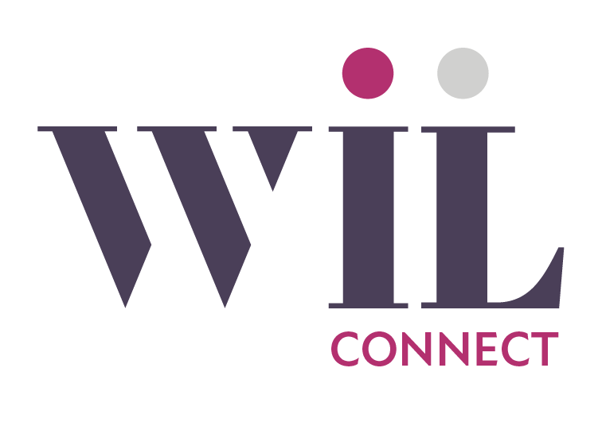

Group Name:__________________________________________________________________________

Group Leader’s Name:___________________________________________________________________

Email / Phone:_________________________________________________________________________

Group Type & Region:___________________________________________________________________

Connect Meeting Day:
☐ Monday ☐ Tuesday ☐ Wednesday ☐ Thursday

☐ Friday ☐ Saturday ☐ Sunday

Connect Meeting Frequency and Time:
☐ Weekly ☐ Bi-Weekly ☐ Monthly

Time:____________ ☐ AM ☐ PM

How does this Connect Group meet the WIL Mission and Vision?
Mission: Empowering a diverse community of women through relevant education, networking and social
opportunities
Vision: That all women are inspired to achieve personal and professional excellence

_____________________________________________________________________________________

_____________________________________________________________________________________

Group Description for the website?

_____________________________________________________________________________________

_____________________________________________________________________________________

Connect Groups are WIL endorsed, led by WIL members.

Connect Leader must be a WIL member in good standing, be willing to adhere to WIL Connect Leader expectations and is responsible for all creation and promotion of marketing for Connect Group. WIL Connect logo must be used in all marketing. Connect Leader promises to refrain from sales or demonstrations of products/services at Connect meetings.

Members Only Facebook page: https://www.facebook.com/groups/WILMembersonly

Turn in application at WIL event or luncheon or send to jpricetober@gmail.com or mail to WIL Events Committee, P.O. Box 6717, Saginaw, MI, 48608.

